Write the following Java classes with the following behaviors. Zip your entire eclipse project folder and save it as lastname.zip (use your own last name). Submit this zip file to BCIT’s SHARE IN server (/in/comp/1451/assignment1 folder) before 11:59 PM, on the night before your class meets for its 9th lesson.
This assignment tests what we have learned in lessons 1, 2, 3, 4, and 5.
The purpose of this assignment is to create two Stores: a book store (class BookStore) and a shoe store (class ShoeStore).
Note the following:
Every instance variable must be very clearly named.
Every instance variable must have accessor and mutator methods.
Extensive JavaDoc comments must be provided as described in the lesson and Appendix J.
Constructors must have parameters for every instance variable, and must call its class’s mutator methods to set the instance variables to the contructor’s parameters.
Every subclass constructor must take parameters for its superclass’s constructor, and call super( ) as its first instruction.
NOTE: some sample data is given in this assignment write-up, along with a sample run of how the program should run, given that sample data. However, your marker will actually test your assignment with other data…a larger sample of books and shoes.
I have put some code in here that you can copy/paste into your classes.

Contents
class BookStore 3
Sample BookStore Run 11
enum BookType 15
class ShoeStore 15
Sample ShoeStore Run 16
enum ShoeType 19
class Store 20
class Address 20
class Book 21
class Author 21
class Date 22
class Name 23
class Shoe 23
enum Material 23
class Item 24

class BookStore
This is a subclass of Store. It also has an instance variable for “specialty”, which is an enum of the following possible values: FICTION, NONFICTION, SCIENCEFICTION, REFERENCE
Note that we can map these enums to Strings (and vice versa) as follows in the BookType enum (see below):
import java.util.Map;
import java.util.HashMap;

public enum BookType {
FICTION("fiction"), NONFICTION("nonfiction"), SCIENCEFICTION("sciencefiction"),
REFERENCE("reference");

private String theBookType;

private static Map<String, BookType> lookup = new HashMap<String, BookType>();

static{
for (BookType b : BookType.values()){
lookup.put(b.getTheBookType(), b);
}
}

private BookType(String theBookType) {
this.theBookType = theBookType;
}

public String getTheBookType() {
return theBookType;
}

// the following method allows me to create a BookType enum from a String!
// e.g. in the Book class, I could set the BookType instance variable to:
// bookType = BookType.get("fiction");
public static BookType get(String theBookType) {
return lookup.get(theBookType);
}
}

Provide an overloaded constructor: one accepts Address, String, and BookType parameters for address, name, and specialty, respectively; the other accepts Address, String, and String parameters for address, name, and specialty, respectively – example: this.specialty = BookType.get(specialty).

Both constructors then call an addBooks() method which creates anonymous objects and adds the following books to its (parent’s) HashMap. The key is the Book Item’s uniqueID String; and the value is the Book.

Kg | Manuf Price $ | Retail Price $ | ISBN | Author | Date Pub. | Title | Genre
0.4 | 2 | 4 | 1234 | Jerome David Salinger (Jan 1, 1919) aka “JD”; fiction writer | May 14 1951 | The Catcher in the Rye | fiction
1 | 11 | 12 | 2345 | Jerome David Salinger (Jan 1, 1919) aka “JD”; fiction writer | Jan 31, 1948 | A Perfect Day for Bananafish | fiction
2 | 33 | 35 | 3456 | Jerome David Salinger (Jan 1, 1919) aka “JD”; fiction writer | Dec 12, 1945 | A Boy in France | fiction
2.1 | 2 | 6 | 4567 | Malcolm Gladwell (Sept 3, 1963); nonfiction writer | Nov 18, 2008 | Outliers | nonfiction
0.5 | 3 | 5 | 5678 | Malcolm Gladwell (Sept 3, 1963); nonfiction writer | Mar 1, 2000 | The Tipping Point | nonfiction

0.01 | 4 | 4 | 6789 | Frederik Pohl (Nov 26, 1919), aka “Paul Dennis Lavond”; science fiction writer | July 4, 1977 | Gateway | science fiction
0.1 | 5 | 11 | abcd | Frederik Pohl (Nov 26, 1919), aka “Paul Dennis Lavond”; science fiction writer | Oct 6, 1937 | Elegy to a Dead Planet: Luna | science fiction
0.8 | 15 | 30 | efgh | Richard Phillips Feynman (May 11, 1918), reference writer | May 20, 1942 | Principle of Least Action in Quantum Mechanics | reference
0.6 | 44 | 45.5 | ijkl | Richard Phillips Feynman (May 11, 1918), reference writer | June 30, 1964 | The Messenger Lectures | reference

1.0 | 3 | 13 | mnop | Richard Phillips Feynman (May 11, 1918), reference writer | Nov 1, 1985 | Surely You’re Joking Mr. Feynman | nonfiction

The BookStore must provide the following methods (see the screenshots for example outputs). One of the methods has been filled in for an example.

import java.util.Collection;
import java.util.Iterator;

class BookStore extends Store
{
private BookType specialty;

public BookStore(Address address, String name, BookType specialty){
super(address, name);
this.specialty = specialty;
addBooks();
}

public BookStore(Address address, String name, String specialty){
super(address, name);
this.specialty = BookType.get(specialty);
addBooks();
}

private void addBooks(){
Date birthDate = new Date(1919, 1, 1);
Name name = new Name("Jerome", "David", "Salinger");
BookType genre = BookType.get("fiction");
Author author = new Author(birthDate, name, genre, "JD");
Date datePublished = new Date(1951, 5, 14);
String title = "The Catcher in the Rye";
Book b = new Book(0.4, 2.0, 4.0, "1234", author, datePublished, title, genre);
addItem(b);

datePublished = new Date(1948, 1, 31);
title = "A Perfect Day for Bananafish";
genre = BookType.get("fiction");
b = new Book(1, 11, 12, "2345", author, datePublished, title, genre);
addItem(b);

datePublished = new Date(1945, 12, 12);
title = "A Boy in France";
genre = BookType.get("fiction");
b = new Book(2, 33, 35, "3456", author, datePublished, title, genre);
addItem(b);

birthDate = new Date(1963, 9, 3);
name = new Name("Malcolm", "Gladwell");
genre = BookType.get("nonfiction");
author = new Author(birthDate, name, genre) ;
datePublished = new Date(2008, 11, 18);
title = "Outliers";
b = new Book(2.1, 2, 6, "4567", author, datePublished, title, genre);
addItem(b);

datePublished = new Date(2000, 3, 1);
title = "The Tipping Point";
genre = BookType.get("nonfiction");
b = new Book(0.5, 3, 5, "5678", author, datePublished, title, genre);
addItem(b);

birthDate = new Date(1919, 11, 26);
name = new Name("Frederik", "Pohl");
genre = BookType.get("sciencefiction");
author = new Author(birthDate, name, genre, "Paul Dennis Lavond") ;
datePublished = new Date(1977, 7, 4);
title = "Gateway";
b = new Book(0.01, 4, 4, "6789", author, datePublished, title, genre);
addItem(b);

datePublished = new Date(1937, 10, 6);
title = "Elegy to a Dead Planet: Luna";
genre = BookType.get("sciencefiction");
b = new Book(0.1, 5, 11, "abcd", author, datePublished, title, genre);
addItem(b) ;

birthDate = new Date(1918, 5, 11);
name = new Name("Richard", "Phillips", "Feynman");
genre = BookType.get("reference");
author = new Author(birthDate, name, genre) ;
datePublished = new Date(1942, 5, 20);
title = "Principle of Least Action in Quantum Mechanics";
b = new Book(0.8, 15, 30, "efgh", author, datePublished, title, genre);
addItem(b);

datePublished = new Date(1964, 6, 30);
title = "The Messenger Lectures";
genre = BookType.get("reference");
b = new Book(0.6, 44, 45.5, "ijkl", author, datePublished, title, genre);
addItem(b);

datePublished = new Date(1985, 11, 1);
title = "Surely You're Joking Mr. Feynman";
genre = BookType.get("nonfiction");
b = new Book(1.0, 3, 13, "mnop", author, datePublished, title, genre);
addItem(b);
}

public void displayAllBooksWrittenByAuthorsOverThisAge(int ageInYears){
Collection<Book> books = getCollectionOfItems(); // From the Store class
Iterator<Book> it = books.iterator();
boolean displayedSome = false;
while(it.hasNext()){
Book b = it.next();
int ageYears = b.getDatePublished().getYear() - b.getAuthor().getBirthDate().getYear();
if(ageYears > ageInYears){
System.out.println(b.getTitle() + " was written by " + b.getAuthor().getName().getLastName() + " at age " + ageYears +
", which is more than " + ageInYears);
displayedSome = true;
}
}
if(displayedSome == false){
System.out.println("No books by authors over age " + ageInYears);
}
}
…all other methods go here too…
}

Sample BookStore Run
Test a BookStore named “Chapters”, with an address of “1234 Main Street, Vancouver, A3A A4A”, and a specialty of “fiction”.

displayAllBooksByEveryAuthor()
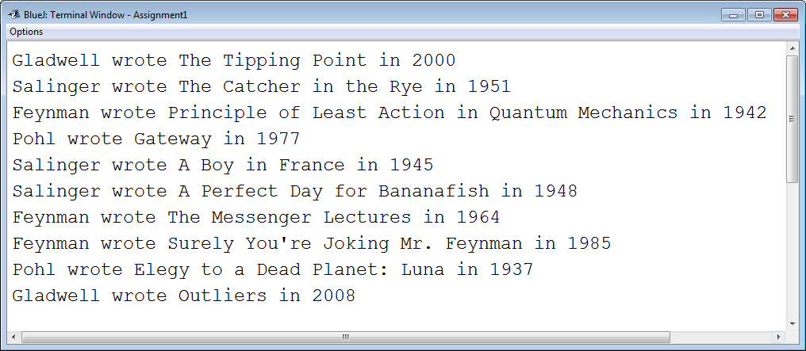

displayAllBooksByAuthor(String lastName)

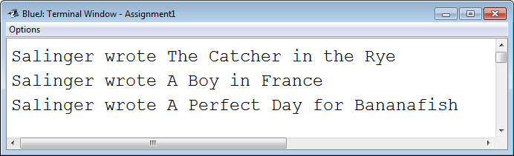

displayAllBooksWrittenBefore(int year)
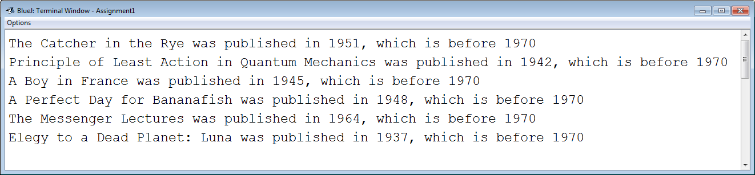

displayTitlesOfBooksWrittenBy(String pseudonym)
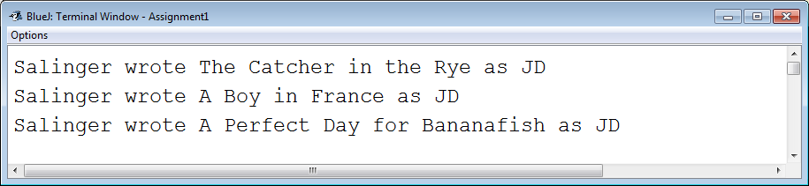

displayAllBooksForGenre(String genre)
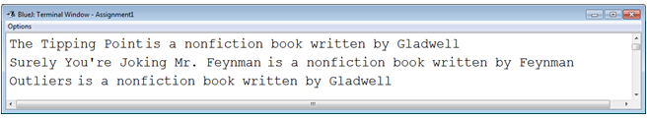

displayTotalWeightKgOfAllBooks()
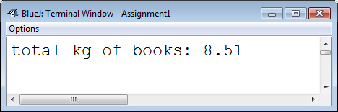

displayAllBooksWrittenByAuthorsOverThisAge(int ageInYears)
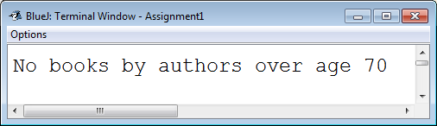
…or…
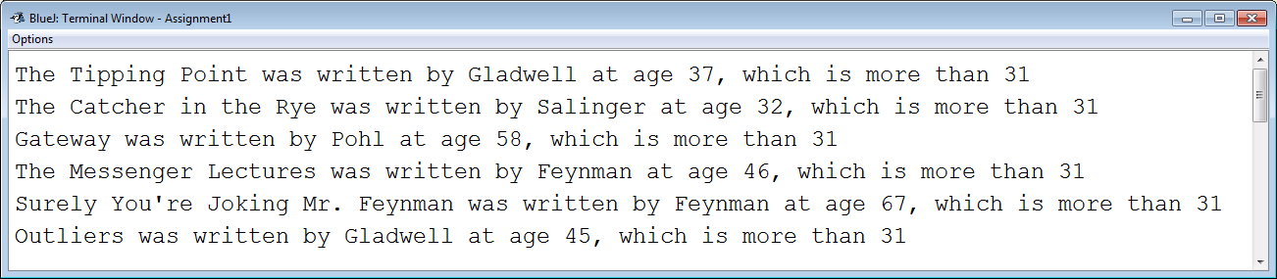

displayAllBooksWrittenByAuthorsBornOn(String dayOfTheWeek)
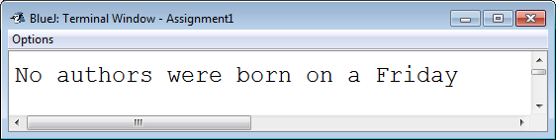
…or…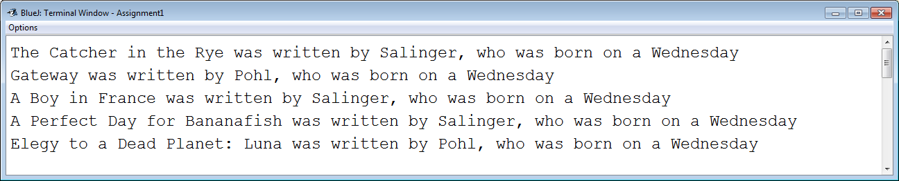

displayAllBooksPublishedOn(String dayOfTheWeek)
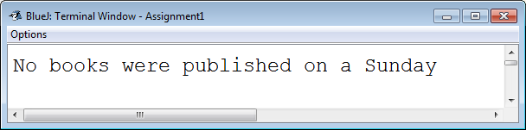
…or…
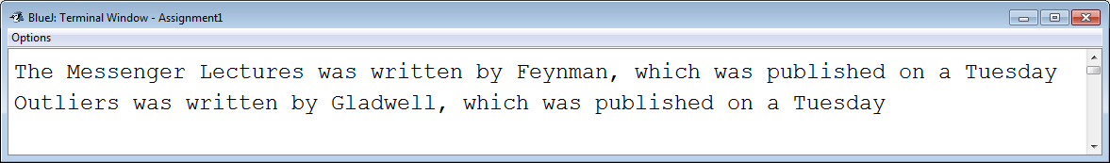

displayAllBooksWrittenByAuthorsWithAPseudonym()
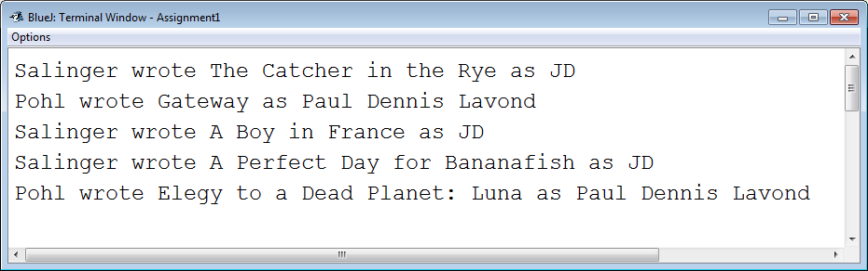

displayBookWithBiggestPercentageMarkup()
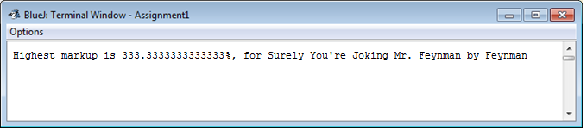
displayAllBooksWrittenOutsideSpecialty()

enum BookType
see above

class ShoeStore
This is a subclass of Store. It also has an instance variable for “department”, which is an enum of the following values: WOMEN, MEN, CHILDREN, SPORTS, DRESS (created similarly to BookType, above).
The ShoeStore class must have similar functionality as the BookStore (above). Its instance variables are:
Department (see above).
The inventory that will be created in the addShoes() method is as follows:
Kg | Manuf Price $ | Retail Price $ | ID | Designer | Size | Material | Color | Department
1 | 58.5 | 90 | Diameter | Skechers | 10 | LEATHER | DARK_GRAY | men
1.15 | 104 | 160 | Wave | Robert Cobbler | 12 | LEATHER | BLACK | dress
1 | 110.5 | 170 | Monet | Geox | 7 | CLOTH | BLUE | men
0.85 | 84.5 | 130 | Camya Multi Glitter | Nine West | 8 | PLASTIC | BLACK | women
0.9 | 97.5 | 150 | Marieclaire | Geox | 10 | PLASTIC | GRAY | women
0.6 | 45.5 | 70 | Balance Of The Force | Stride Rite | 9 | RUBBER | GRAY | children
0.7 | 39 | 60 | Top-Sider Unisex Bluefish H&L | Sperry | 9 | CLOTH | ORANGE | children
0.85 | 32.5 | 50 | Lite Kicks Rainbow Sprite | Skechers | 10 | PLASTIC | PINK | children
0.5 | 39 | 60 | Toachi | Robert Cobbler | 5 | CLOTH | BLUE | children
1.2 | 117 | 180 | Jordan Ace 23 II | Nike | 13 | RUBBER | WHITE | sports

This class’s methods must have the same sort of output as the BookStore methods.
displayAllShoesAndDesigners()
displayAllShoesByDesigner(String designerName)
displayAllShoesMadeOf(Material material)
displayAllShoesMadeOf(String material)
displayNumberOfShoesDesignedBy(Name designer)
displayNumberOfShoesDesignedBy(String designerLastName)
displaySmallestShoeSize ()
displayTotalWeightKgOfAllShoes()
displayAllShoesOfThisMaterialMadeByThisDesigner(Material m, Name designer)
displayAllShoesNotInMatchingStore() // e.g. For a shoe store with department “WOMEN”, show all the shoes of type MEN, CHILDREN, SPORTS, and DRESS

Sample ShoeStore Run
Test a ShoeStore named “My Shoes”, with an address of “789 East 1st Street, West Vancouver, V3A 7A4”, which specializes in selling children’s shoes.

displayAllShoesAndDesigners()

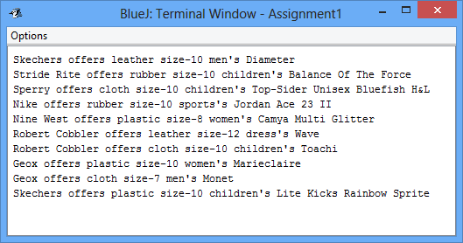

displayAllShoesByDesigner(String designerName)

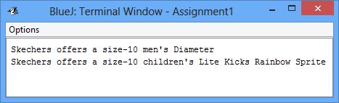

displayAllShoesMadeOf(Material material)

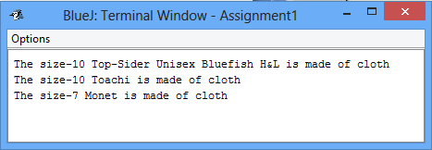

displayAllShoesMadeOf(String material)

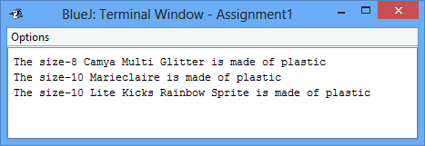

displayNumberOfShoesDesignedBy(Name designer)

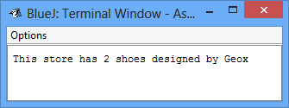

displayNumberOfShoesDesignedBy(String designerLastName)

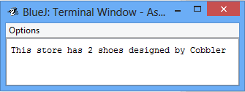

displaySmallestShoeSize ()

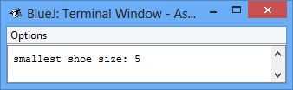

displayTotalWeightKgOfAllShoes()

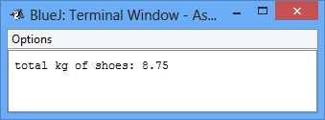

displayAllShoesOfThisMaterialMadeByThisDesigner(Material m, Name designer)

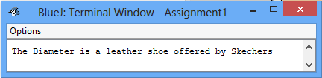

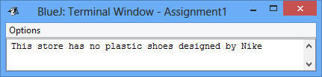

displayAllShoesNotInMatchingStore()
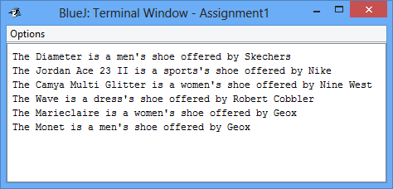
If it is still unclear what displayAllShoesNotInMatchingStore() does, please complete BookStore displayAllBooksWrittenOutsideSpecialty() first. The two methods behave the same. Shoe.type is to ShoeStore.department as Book.genre is to Book.author.specialty.

enum ShoeType
see ShoeStore, above, for the enums

class Store
This is the parent class of all other Stores.
It has the following instance variables:
A streetAddress, of class Address.
A name, of class String.
The store contains a HashMap of Items. The key of each item is its uniqueID String. For example, an Item may have a uniqueID of “abc123”. The value is the item itself.
This class offers very useful, generic methods such as:
public void addItem(Item item){
itemsForSale.put(item.getUniqueID(), item);
}

public Item getItemByKey(String key){
return itemsForSale.get(key);
}
public Collection getCollectionOfItems(){
return itemsForSale.values();
}

class Address
Contains instance variables for street number (String), street name (String), city (String), postal code (String).

class Book
Has instance variables for author (class Author), datePublished (class Date), title (String), genre (bookType enum). Note that a Book also has an ISBN (a String). In our class we will NOT have an ISBN instance variable. Our Book class in fact uses its parent class’s uniqueID variable and methods: e.g. class Book has methods called setISBN() and getISBN(), but in turn it just calls setUniqueID() and getUniqueID() from the Item class. This class also has a getYearPublished() convenience function, as well as getAuthorFullName(), and getGenreString() which returns a String such as “fiction” when its BookType is BookType.FICTION (return genre.getTheBookType();). Book is a subclass of class Item.

class Author
Has instance variables for birthDate (class Date), name (class Name), genre (enum BookType), and pseudonym (String).

class Date
Has instance variables for year (int), month (int), dayOfTheMonth (int). Has accessor methods for each, plus getMonthName( ) (e.g. returns “January”), getSuffix(e.g returns “st” for 1, “nd” for 2, “rd” for 3, “th” for 4, etc…), and getDayOfWeek() (e.g. returns “Friday”). Here is an algorithm to get the day of the week from a date:
Example date: May 17th, 1989
Step 1: determine how many twelves fit in the last two digits of the year
e.g. there are 7 twelves in 89 (12 * 7 = 84) Sum is 7
Step 2: determine the remainder from step 1
e.g. 89 – 84 = 5 remainder Sum is 7 + 5
Step 3: determine how many fours fit into the remainder from step 2
e.g. 1 four fits into five Sum is 7 + 5 + 1
Step 4: Add the date of the month
e.g. 17 for the 17th Sum is 7 + 5 + 1 + 17
Step 5: Add the month code (see below)
e.g. 2 for May Sum is 7 + 5 + 1 + 17 + 2
Step 6: Mod the sum by 7
7 + 5 + 1 + 17 + 2 = 32; 32 % 7 = 4 = WEDNESDAY
Match this number with the day of the week:
Saturday | Sunday | Monday | Tuesday | Wednesday | Thursday | Friday
0 | 1 | 2 | 3 | 4 | 5 | 6
Month codes:
January: 1 | February: 4 | March: 4
April: 0 | May: 2 | June: 5
July: 0 | August: 3 | September: 6
October: 1 | November: 4 | December: 6

For dates in the 1700s, add 4. For dates in the 1800s, add 2. For dates in the 1900s, add nothing. For dates in the 2000s, add 6. For any other years, simply return “Dunno”.
Add 6 for January or February of a leap year.
The mutators do not permit invalid dates such as February 30th.

class Name
Has instance variables for first name (String), middle name (String), last name (String). Overload the constructor to allow for people that have one (e.g. “Madonna” or “Cher”), or two (e.g. “Tiger Woods”), or three names (e.g. “Andrew Lloyd Webber”).
In addition to all regular accessor and mutator methods, include a method getFullName() which returns the full name (such as “Madonna”, or “Tiger Woods”, or “Andrew Lloyd Webber”).

class Shoe
Has instance variables for material (enum Material), size (int), designer (Name class; e.g. “Nike” or “Manolo Blahnik”), shoe type (enum, and color (class java.awt.Color; for example, java.awt.Color.gray). Shoe is a subclass of class Item. Note that a Shoe also has a description (a String). In our class we will NOT have an description instance variable. Our Shoe class in fact uses its parent class’s uniqueID variable and methods: e.g. class Shoe has methods called setDescription() and getDescription(), but in turn it just calls setUniqueID() and getUniqueID() from the Item class.

enum Material
Has values for PLASTIC, LEATHER, RUBBER, CLOTH

class Item
Has instance variables for weightKg (double), manufacturingPriceDollars (double), suggestedRetailPriceDollars (double), uniqueID (String).

Start early. There are lots of classes to write:
